Internship in Human resources department
Henkel operates worldwide with leading brands and technologies in three exciting business areas: Laundry & Home Care, Beauty Care and Adhesive Technologies. Our success is built on constant innovation and people who strive for excellence. Working at Henkel is much more than just a job. It´s a passion. Have you got what it takes?
HR Reporting Specialist
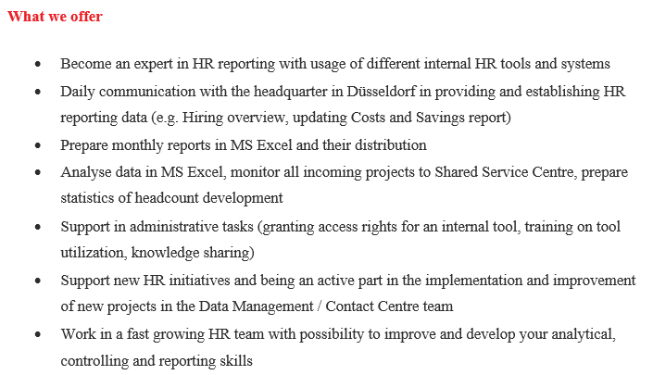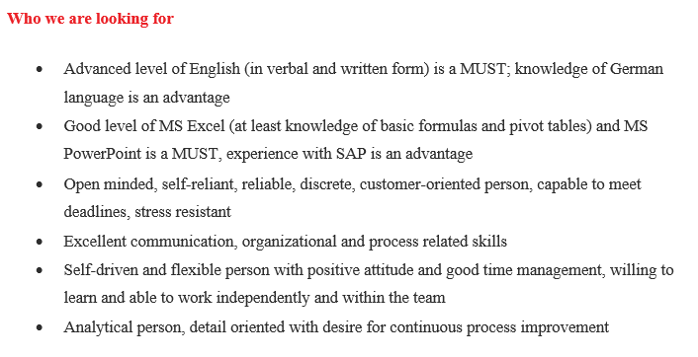
In case of interest, do not hesitate to send us your Curriculum Vitae and cover letter in English language. We will contact only candidates who match a profile we are looking for. Thank you for your understanding.
Discover our winning culture: www.henkel.com/career

Remuneration
It is a combination of Erasmus grant and Henkel payout. For Slovakia, according to the current Erasmus guidelines, there is a valid remuneration in the amount of 400€ per month for the amount of hours worked comparable to the full time employee. The total amount payable to the intern varies from 250€ per month up to 400€ per month. This depends on the length of stay of respective Intern and on assessment done by the nominated mentor from the respective department.
Example:
Five months Internship: (one month break for exams completion)
Grant: 5 * 400 = 2000€
Henkel fix: 5 * 250 = 1250€
Henkel bonus*: 5 * 150 = 750€
Total: 2000€ + 1250€ + 750€ = 4000€
* paid out after 5 months Internship completion, amount dependent on the Mentor´s assessment.
How to apply
Write an email with your CV on the following email address (internsbratislavahenkel@henkel.com) with the wished department name and you will be contacted back in a due course.

