Internship at the International Education Office,
University of Agder, Norway

The University of Agder (UiA) is looking for an intern / Erasmus+ trainee for 8 – 9 months to start as soon as possible, ideally by the middle of November 2017, finishing in the middle of August. Early January to the middle of August is also a possibility.
Who are we?
The University of Agder (UiA) is a young and dynamic university, recognised for its modern teaching and research facilities and innovative use of technology and communication media. UiA has approximately 12 000 students in two campuses in the very south of Norway. The Intern will be based in the main campus in the city of Kristiansand and will work closely with the staff from the International Education Office. The main work-place will be our soon-to-open ‘Global Hub’, an area designated to welcome and support International and Norwegian students, guests and staff.

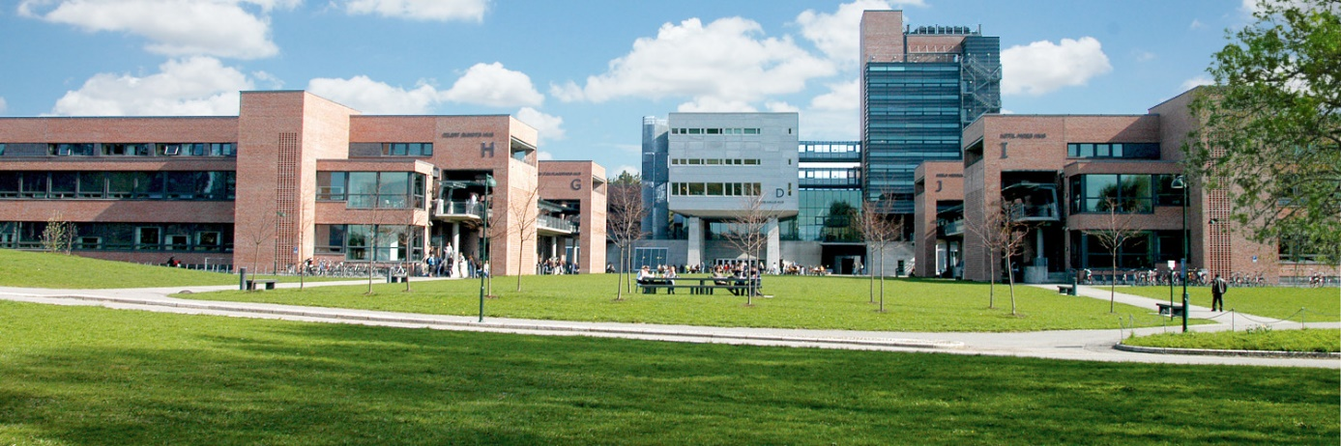

Your fields of responsibility:
- First point of contact for Global Hub
- Supporting mobility team (incoming and outgoing students)
- Help with marketing / promotion, social media and public relations
- General administrative support to team
- Help with organising activities in Global Hub and for students
- Support with promotion and running of our Summer School in European Integration

Who are we looking for?

- Student enrolled at a bachelor’s or master’s level or a recent graduate
- Fluent English spoken and written
- Strong communication and customer service skills
- Computer skills
- Marketing and administrative experience
- Flexible and able to work independently

Payment:
The internship is financed through the Erasmus+ program. The exact amount of your grant depends on your home country. For more detailed information please contact the International office of your university.
What can we offer you?
- Varied work experience
- Free single-room accommodation in student housing
- Free Norwegian Language course
- The opportunity to join international students for trips and events

To apply:

- Send your CV together with a one-page cover letter describing why you are interested in the internship
- Supply the names and contact details of two referees (teachers, former employers, etc.) who can be contacted by us
- A Skype interview will be required if short-listed
- Please send an e-mail to int-kontor@uia.no if you have any questions about the position
- Applications should be sent by e-mail to aase.galteland@uia.no by 20th October 2017

